Electrical Science Formula Sheet
i = dq/dt $Q=\int_{0}^{t}{idt}$ v_{ab} = dw/dq p = dw/dt = vi $w=\int_{to}^{t}{Pdt}$ v = iR G=1/R p = vi = i²R = v²/R
$\sum_{n=1}^{N}{i_{n}}=0$ $\sum_{n=1}^{N}{v_{n}}=0$ Series: R_{eq} = R₁ + R₂ + … + R_{n} Parallel: 1/R_{eq} = 1/R₁ + 1/R₂ + … + 1/R_{n}
v_{n} = (R_{n}*v)/(R₁+R₂+…+R_{N}) q = Cv C=ɛA/d i = C dv/dt $v=\frac{1}{C}\int_{to}^{t}{idt+v(to)}$ w=Cv²/2
Parallel: C_{eq} = C₁ + C₂ + …+C_{n} Series: 1/C_{eq} = 1/C₁ + 1/C₂ + …+ 1/C_{n} v = L di/dt L = N²μA/l
$i=\frac{1}{L}\int_{to}^{t}{v(t)dt+i(to)}$ w=Li²/2 Series: L_{eq} = L₁ + L₂ + …+ L_{n} Parallel: 1/L_{eq} = 1/L₁ + 1/L₂ + …+ 1/L_{n}
Capacitor discharge: v(t) = V₀e^{-t/τ} τ = RC Inductor discharge: i(t) = I₀e^{-t/τ} τ = L/R
Capacitor step response v(t) = v(ꝏ) + [v(0⁺) – v(ꝏ)]e^{-t/τ}
Inductor step response i(t) = i(ꝏ) + [i(0⁺) – i(ꝏ)]e^{-t/τ}
Complex Variables: z = x +jy z = re^{jθ} $r=\sqrt{x^{2}+y^{2}}$ $θ=\tan^{-1}(\frac{y}{x})$ z* = x-jy z* = re^{-jθ}
z₁z₂ = r₁ r₂e^{j(θ1+ θ2)} z₁/z₂ = (r₁ /r₂)e^{j(θ1- θ1)} impedance: Z_{C} = 1/jωC Z_{L} = jωL Z_{R} = R
Steps to determine the node voltages:
  - Select a node as the reference node.
  - Assign voltages v₁,v₂,…,v_{n-1} to the remaining n-1 nodes. The voltages are referenced with respect to the reference node.
  - Apply KCL to each of the n-1 non-reference nodes. Use Ohm’s law to express the branch currents in terms of node voltages.
  - Solve the resulting simultaneous equations to obtain the unknown node voltages.
Steps to determine the node voltages with voltage source between nodes:
- A super-node is formed by enclosing a (dependent or independent) voltage source connected between two non-reference nodes and any elements connected in parallel with it.
- Take off all voltage sources in super-nodes and apply KCL to super-nodes.
- Put voltage sources back to the nodes and apply KVL to relative loops.
Steps to determine the mesh currents:
  - Assign mesh currents i₁, i₂, …, i_{n} to the n meshes.
  - Apply KVL to each of the n meshes. Use Ohm’s law to express the voltages in terms of the mesh currents.
  - Solve the resulting n simultaneous equations to get the mesh currents.

Steps to determine the mesh currents with current source:
A super-mesh results when two meshes have a (dependent or independent) current source in common.
1- We create a super-mesh by excluding the current source and any elements connected in series with it.
2- Write KVL in the super-mesh using the loop currents of the two adjacent meshes.
3- The sum or the difference of the two mesh currents equals the current source in the common branch between the two meshes.
Thevenin’s Theorem
It states that a linear two-terminal circuit can be replaced by an equivalent circuit consisting of a voltage source V_{TH} in series with a resistor R_{TH},
- V_{TH} is the open-circuit voltage at the terminals.
- R_{TH} is the input or equivalent resistance at the terminals when the independent sources are turned off.
- Independent sources are turned off by replacing a Voltage source by a short circuit and current source by open circuit.
Norton’s Theorem
It states that a linear two-terminal circuit can be replaced by an equivalent circuit of a current source I_{N} in parallel with a resistor R_{N}.
- I_{N} is the short circuit current through the terminals.
- R_{N} is the input or equivalent resistance at the terminals when the independent sources are turned off.
- Independent sources are turned off by replacing a Voltage source by a short circuit and current source by open circuit.
Maximum Power Transfer
For maximum Power transfer load resistor should equal Thevenin’s resistor
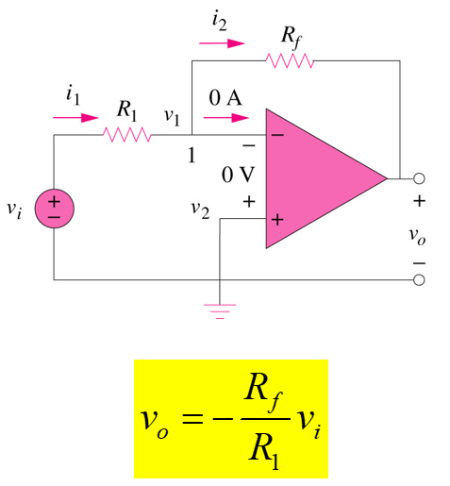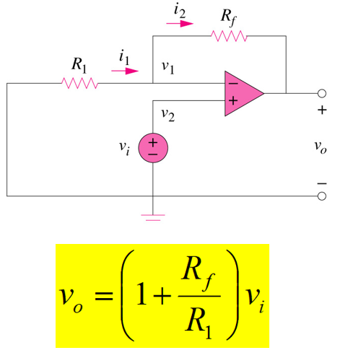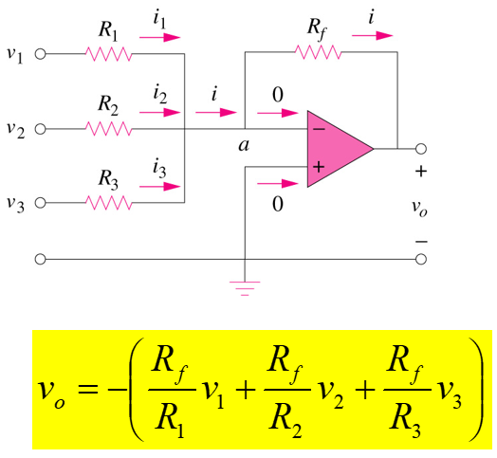
Capacitor
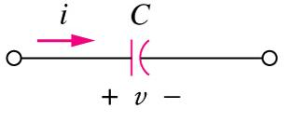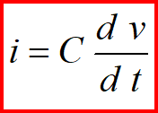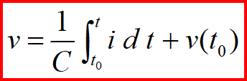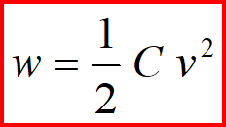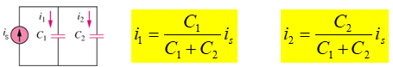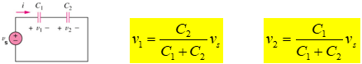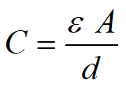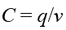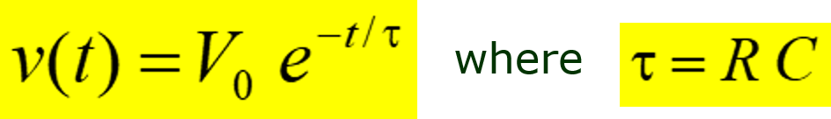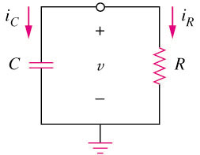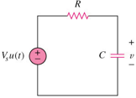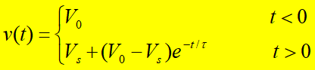
Inductor
